**Winter 2025**

**DePaul University**

**ECO106 – Principles of Macroeconomics**

**Professor: Dr. Jaejoon Woo**

**Office: 6218, DePaul Center (Loop)**

**Email:** [**jwoo1@depaul.edu**](mailto:jwoo1@depaul.edu)

**Phone: 312/362-5585**

**Homepage:** [**www.jaejoonwoo.org**](http://www.jaejoonwoo.org)

**Office Hours: Mondays 4:00-5:00pm or by appointment (via live Zoom)**

**Special note:**This syllabus is for the “**online asynchronous**” format of the class.

**Communication via Email:** Please use ECO106 as a prefix on the subject line and that will get my attention immediately. **__________________________________________________________________________**

**Goal of this course**: This course provides an introduction to economic issues and basic economic principles and methods. We concentrate on “macroeconomics,” the study of the economy as a whole. We explore key macroeconomic relationships and policy issues ranging from business cycles (boom and recession), financial crisis, productivity and economic growth, wage inequality, unemployment, inflation, monetary and fiscal policy, financial markets, foreign exchange rates, to international trade and capital flows such as trade deficit/surplus. We develop and use basic theoretical frameworks to study how the economy works and their application to policy debates and major economic events around the world, such as the 2007-2009 global financial crisis or the COVID-19 pandemic. We extensively cover the U.S. and international data.

**Prerequisites**: There are no prerequisites. This course is highly analytical, but the level of mathematics will be kept at the minimum (elementary algebra).

**Course Materials**

Many chapters in Mankiw textbook will serve as basic readings, but my lecture slides, class handouts, and selected articles will be the primary resources for the course.

1. **Textbook:** N. Gregory Mankiw, **Brief Principles of Macroeconomics**, 10th edition, Cengage.

Note that earlier editions (say, 9th, 8th or 7th edition) or any format (e-Textbook, loose leaf, hardcover) can be used. You will find this best seller text provides a clear and comprehensive explanation for otherwise complex macroeconomic issues.

1. **Lecture slides/class handouts** will be posted in D2L on a regular basis (<https://d2l.depaul.edu/>).
2. For interesting discussion of current issues & macroeconomics, you will find Gregory Mankiw’s blog to be informative: <http://gregmankiw.blogspot.com>

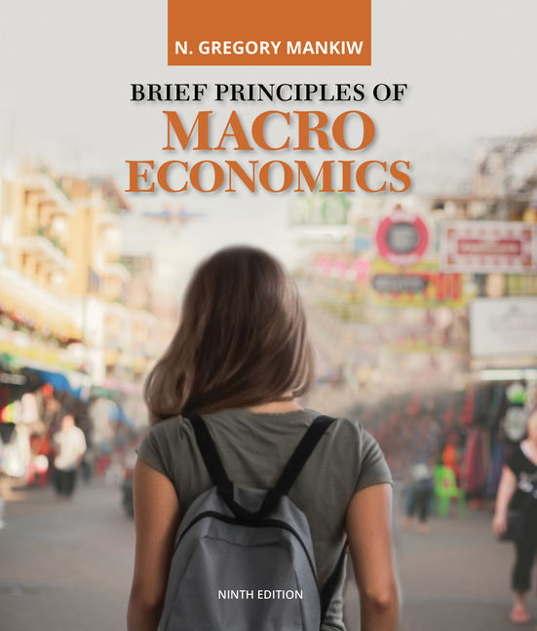**FYI: textbook cover (10th edition) FYI: textbook cover (9th edition)**

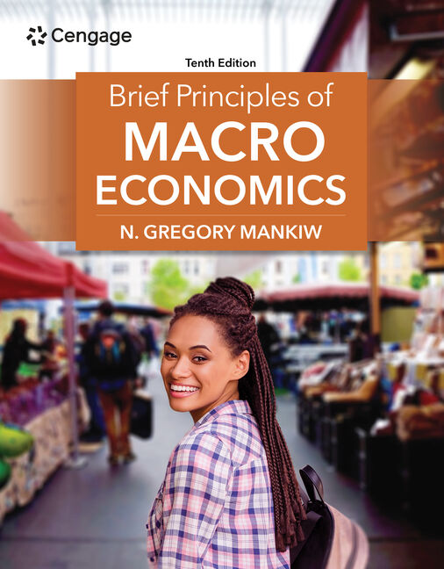

**Course Requirements:** It is very important to closely follow lectures (online), since the materials covered in lectures form the core of the course.

**3 requirements**: **2 Midterm Exams, 1 Final Exam, and Problem Sets**

(1) There will be two midterms and one final. **The first midterm exam is tentatively scheduled on Jan 28, the second midterm on Feb 21, and the final on Mar 11 (to be confirmed later).** All the exams will be take-home exams (i.e., open-book test). Further details will be provided in advance before the exam is assigned and posted in D2L.

(2) **Problem sets (homework):** (up to) 6 Problem sets (mostly from textbook) will be assigned in about each week. Each problem set will be graded on a simple scale 0 (no submission) and 1 (submission). Thus, it is advisable to submit even the partial work.

**Grade:** Course grade will be determined by two midterms (48%=2*24%), the final (34%), problem sets (18%). Note that D2L records the data on class engagement.

**Grading Scale:** A=94% and above; 88%≤A-<94%; 82%≤B+<88%; 77%≤B<82%; 72%≤B-<77%;

67%≤C+<72%; 63%≤C<67%; 59%≤C-<63%; 56%≤D+<59%; 53%≤D<56%;

50%≤D-<53%; and F<50%.

**General policy**

You should be aware of and abide by the University’s policy on academic integrity (<http://academicintegrity.depaul.edu>). Also, the instructor reserves the right to change the topics or schedules if necessary.

**Dean of Students**

The Dean of Students Office (DOS) helps students in navigating the university, particularly during difficult situations, such as personal, financial, medical, and/or family crises. DOS assists students with Absence Notifications to faculty, Late Withdrawals, and Community Resource Referrals. You may contact DOS at <http://studentaffairs.depaul.edu/dos/>.

**Special Needs**

Students who feel they may need an accommodation based on the impact of a disability should contact me privately to discuss their specific needs. All discussions will remain confidential. To ensure that you receive the most appropriate accommodation based on your needs, contact me as soon as possible in the quarter (preferably the first week of class) and make sure that you have contacted one of the Center for Students with Disabilities Offices for support and additional service: Lincoln Park: Student Center 370, (773)325-1677; Loop: Lewis Center 1420. (312)362-8002. You may also visit: <https://offices.depaul.edu/student-affairs/resources/faculty-staff/faculty-questions/Pages/services-for-students-with-disabilities.aspx>

**Makeup Exams**

In cases of severe illness or other extenuating circumstances, students may request a makeup exam. Prior to the exam or as soon as possible afterward, you must inform me and obtain permission for your absence (i.e., no submission before the deadline). Appropriate documentation is required. I reserve the right to verify the request and may apply a grade penalty or assign a grade of zero if proper procedures are not followed. Please note that there will be no opportunities for extra credit work to compensate for poor performance on the midterm or final exams. It is important to focus on performing well on these assessments and seek timely assistance, such as during office hours, to ensure a thorough understanding of the material. Please plan and study accordingly.

**Desire2Learn (D2L)**

All class material will be posted on D2L ([https://**d2l**.**depaul**.edu/](https://d2l.depaul.edu/)). All communication will be through D2L, although I will occasionally send emails as needed. “I DIDN’T CHECK D2L” will not be a valid excuse for missing announcements or assignments.

**Special Notice on Online Class, Discussion, and Emails**

1. The course will be delivered in an "**asynchronous**" online format. This means all the lectures will be pre-recorded and posted on D2L.

So, it will NOT require us to meet up virtually at a set time and day, unlike the case of live ZOOM sessions.

For your reference, a weekly video lecture will be posted on Tuesdays **Jan 7, Jan 14, Jan 21, Jan 28, Feb 4, Feb 11, Feb 18, Feb 25, Mar4, Mar 11** (3-hour lecture for each week except for the weeks when the midterm exams are assigned—see schedule next page).

(2) To address individual students' questions and concerns, I will hold a weekly office hour via live ZOOM.

1. Both midterm and final exams will be take-home exams (open-book test). Further details will be provided in advance before the exam is assigned and posted in D2L.
2. In addition to my pre-recorded lecture (which will be the main medium of delivering the lecture), I will post the lecture slides on D2L.
3. Check D2L frequently, especially the 'News Items' and 'Content' sections, where I post announcements and class materials, respectively.

**D2L will be the primary source of class information and course materials.**

1. Please read the Zoom instruction to make yourself familiar with it so that it comes handy whenever you need it.

**SCHEDULE**

________________________________________________________________________

* This is only tentative and may have to be modified if necessary.

Lecture 1 (Jan 7, 3hours):Overview of the US and World Economy

Data of Macroeconomics

Lecture 2 (Jan 14, 3 hours): Data of Macroeconomics, and National Income

Lecture 3 (Jan 21, 3 hours): Income Distribution

Saving and Investment in the Closed Economy

Lecture 4 (Jan 28, 1.5 hours): Trade Balance, and Balance of Payments

**Jan 28: First midterm take-home exam (open-book test) is assigned and due by Feb 4**

Lecture 5 (Feb 4, 3 hours): Money and Inflation

Lecture 6 (Feb 11, 3 hours): Financial Markets and Financial System

Lecture 7 (Feb 18, 3 hours): Financial Markets and Financial System

**Feb 21: Second midterm take-home exam (open-book test) is assigned and due by Feb 28**

Lecture 8 (Feb 25, 1.5 hours): Economic Growth

Lecture 9 (Mar 4, 3 hours): Economic Growth

Business Cycle: AD-AS Model

Lecture 10 (Mar 11, 3 hours): Business Cycle: AD-AS Model

Monetary and Fiscal Policy and AD-AS Model

**Final take-home exam will be posted Mar 11 and due Mar 19 (to be confirmed later)**

**_____________________________________________________________________________**

**Suggested Reading List** (**\*** indicates a more important reading)

**1. Overview of the US and Global Economy**

Readings: * Lecture note

* The Global Pandemic and U.S. and World Economic Outlook

“[Federal Reserve issues FOMC statement](https://www.federalreserve.gov/monetarypolicy.htm),” Federal Reserve Board, December 17-18, and

Quarterly Economic Projections on December 18, 2024.

“[Recent Economic and Financial Developments](https://www.federalreserve.gov/monetarypolicy/2024-07-mpr-summary.htm),” in Monetary Policy Report, Federal Reserve  
Board, July 5, 2024.

“[Policy Pivot, Rising Threats](https://www.imf.org/en/Publications/WEO/Issues/2024/10/22/world-economic-outlook-october-2024),” IMF, World Economic Outlook, October 2024.

“[Macro Outlook 2025: Tailwinds (Probably) Trump Tariffs](https://www.goldmansachs.com/insights/goldman-sachs-research/macro-outlook-2025--tailwinds--probably--trump-tariffs),” Goldman Sachs, November 14, 2024.

* Policy Response to the Pandemic

“[Federal Reserve Announces Extensive New Measures to Support the Economy](https://www.federalreserve.gov/newsevents/pressreleases/monetary20200323b.htm),” Federal Reserve Board, March 23, 2020.

“[What's in the nearly $2 trillion U.S. Senate Coronavirus Stimulus](https://www.reuters.com/article/us-health-coronavirus-usa-bill-factbox/factbox-whats-in-the-nearly-2-trillion-u-s-senate-coronavirus-stimulus-idUSKBN21B37G)?” Reuters, March 24, 2020.

* 2007-09 Financial Crisis and Great Recession

“[The housing bubble, the credit crunch, and the Great Recession: A reply to Paul Krugman](https://www.brookings.edu/blog/ben-bernanke/2018/09/21/the-housing-bubble-the-credit-crunch-and-the-great-recession-reply-to-paul-krugman/),” Ben Bernanke, Sept 21, 2018.

**2. Data of Macroeconomics**

Readings: * Lecture note

*Mankiw, Ch.5. Measuring a Nation’s Income;

*Ch. 6. Measuring the Cost of Living;

*Ch. 10. Unemployment and Its Natural Rate.

* Major Sources of Macroeconomic Data

The U.S. economy

[FRED (federal reserve economic data) by St. Louis Fed](https://fred.stlouisfed.org/?gclid=CjwKCAjw9MuCBhBUEiwAbDZ-7qNU0fVUGPN-Sc2W8AjAvi9_eamYY_5874wBxCNYJ0LP9EUXIgPxwBoCQo8QAvD_BwE)* (this is an excellent comprehensive database including US GDP, labor, trade, interest rates, exchange rates as well as international data)

[Bureau of economic analysis](https://www.bea.gov/data) (US GDP, international trade and balance of payment, etc)

[Bureau of labor statistics](https://www.bls.gov/) (US unemployment, CPI, etc)

[Congress budget office](https://www.cbo.gov/data/budget-economic-data) (US budget and economic data)

International data

[OECD (Organization for Economic Cooperation and Development) Statistics](https://stats.oecd.org/)*

[IMF (International Monetary Fund) World Economic Outlook database](https://www.imf.org/en/Data)

[World Bank’s World Development Indicators*](https://datacatalog.worldbank.org/dataset/world-development-indicators)

**3. National Income, and Saving and Investment**

Readings: * Lecture note and *Mankiw, Ch. 8. Saving, Investment, and the Financial System**.**

Additional readings (optional):

“[Excess Savings during the COVID-19 Pandemic](https://www.federalreserve.gov/econres/notes/feds-notes/excess-savings-during-the-covid-19-pandemic-20221021.html),” FEDS Notes, Federal Reserve Board, October 21, 2022.

*“[Spendthrift Nation](https://www.frbsf.org/research-and-insights/publications/economic-letter/2005/11/spendthrift-nation/),” FRBSF Economic Letter, Nov. 10, 2005.

**4. Trade Balance, and Balance of Payment Accounts**

Readings: * Lecture note and *Mankiw, Ch.13. Open-Economy Macroeconomics: Basic Concepts.

Additional readings (optional):

“[The U.S. Trade Deficit: How Much Does It Matter?](https://www.cfr.org/backgrounder/us-trade-deficit-how-much-does-it-matter),” Council on Foreign Relations, March 8, 2019.

* Exchange Rates

“[Chapter 7. Currency Market and Exchange Rates](https://www.govinfo.gov/app/collection/ERP/),” in Economic Report of the President, Feb 2007, pp.149-166.

**5. Money and Inflation**

Readings: * Lecture note and *Mankiw, Ch.11. The Monetary System, and Ch.12. Money Growth and Inflation.

* Money, Inflation, and Interest Rates

“[The Great Inflation (1965–1982)](https://www.federalreservehistory.org/essays/great-inflation),” Michael Bryan, Federal Reserve History, November 22, 2013.

“[The Biden Stimulus Is Admirably Ambitious. But It Brings Some Big Risks, Too](https://www.washingtonpost.com/opinions/2021/02/04/larry-summers-biden-covid-stimulus/),” Lawrence Summers, Washington Post Feb 4, 2021.

“[COVID-19 inflation was a supply shock](https://www.brookings.edu/articles/covid-19-inflation-was-a-supply-shock/#:~:text=In%20the%20aftermath%20of%20COVID,drivers%20in%20COVID%2D19%20inflation.),” Brookings Institution, August 15, 2024.

* The Fed, Money Supply, and Monetary Policy Tools

“[The Puzzle of Low Interest Rates](https://www.nytimes.com/2020/12/04/business/low-interest-rates-puzzle.html),” Gregory Mankiw, New York Times, Dec 4, 2020.

*“[Why Are Interest Rates So Low?](https://www.brookings.edu/blog/ben-bernanke/)” Ben Bernanke, Mar 30 and 31, Apr 1 and 13, 2015.

“[What Tools Does the Fed Have Left?](https://www.brookings.edu/blog/ben-bernanke/)” Ben Bernanke, Mar 18 and 24, Apr 11, 2016.

**6. Financial Markets and Financial System**

Readings: * Lecture note and *Mankiw, Ch. 9. The Basic Tools of Finance**.**

* Bond Market, Interest Rates, and Stock Market

*“[Long-Term Interest Rates](http://www.federalreserve.gov/newsevents/speech/bernanke20130301a.htm),” Ben S. Bernanke, March 1, 2013.

“[Trendspotting in Asset Markets](http://www.nobelprize.org/nobel_prizes/economic-sciences/laureates/2013/popular-economicsciences2013.pdf),” The Royal Swedish Academy of Sciences has decided to award The Sveriges Riksbank Prize in Economic Sciences in Memory of Alfred Nobel for 2013 to Eugene Fama, Lars Hansen, and Robert Shiller, October 14, 2013.

“[As US Rate Cuts Near, Economic ‘Soft-Landing’ Odds Could Dictate Stock Performance](https://www.reuters.com/markets/rates-bonds/us-rate-cuts-near-economic-soft-landing-odds-could-dictate-stock-performance-2024-08-26/),” Reuters August 26, 2024.

**7. Economic Growth**

Readings: * Lecture note and *Mankiw, Ch. 7. Production and Growth

Additional readings (optional):

*“[Chapter 2.Productivity Growth](http://www.gpoaccess.gov/eop/2007/2007_erp.pdf),” in Economic Report of the President, 2007, pp.45-62.

“[Is Slow Still the New Normal for GDP Growth?](https://www.frbsf.org/economic-research/publications/economic-letter/2019/june/is-slow-still-new-normal-for-gdp-growth/)” John Fernald and Huiyu Li, FRBSF Economic Letter, June 24, 2019.

“[Why Some Nations Are Rich and Others Poor?](https://www.nobelprize.org/prizes/economic-sciences/2024/press-release/),” the Sveriges Riksbank Prize in Economic Sciences in Memory of Alfred Nobel 2024, 14 October 2024.

**8. Aggregate Demand and Supply**

# Readings: *Lecture note and *Mankiw, Ch.15. Aggregate Demand and Aggregate Supply

Additional readings (optional):

*“[The US Business Cycle Expansions and Contractions](http://www.nber.org/cycles.html),” NBER Business Cycle Dating Committee.

“[Learning from a Century of US Recessions](https://www.goldmansachs.com/insights/pages/learning-from-a-century-us-recessions/report.pdf),” US Economics Analyst, Goldman Sachs, Jan. 20, 2019.

“[Chapter 2: The Year in Review and the Years Ahead](https://www.govinfo.gov/app/collection/erp/2022),” Economic Report of the President, March 2024.

* The Great Depression in the 1930s, Today’s Japan and Europe Problem, and the 2007-09 Great Recession, and the Global Pandemic

Readings: * Lecture note

**9. Monetary Policy and Aggregate Demand**

Readings: *Lecture note on monetary policy and the AS-AD Model, and the inflation-unemployment relationship; and *Mankiw, Ch.16. The Influence of Monetary and Fiscal Policy on Aggregate Demand; and Ch. 17. The Short-Run Trade-Off between Inflation and Unemployment.

(Note that Chapter 17 presents the Phillips curve in a slightly different way from the way we do in class. It emphasizes the idea of a vertical long-run Phillips curve, whereas in class we emphasize the relationship between the change in inflation and unemployment. These approaches are complimentary.)

Additional readings (optional):

“[What is the Phillips curve (and why has it flattened)?](https://www.stlouisfed.org/open-vault/2020/january/what-is-phillips-curve-why-flattened)” St. Louis Fed, Jan 15, 2020.

**10. Fiscal Policy and Aggregate Demand**

Readings: *Lecture note and Mankiw, Ch. 16. The Influence of Monetary and Fiscal Policy on Aggregate Demand

Additional readings (optional):

"[A Debt Crisis Is on the Horizon](https://www.washingtonpost.com/opinions/the-debt-crisis-is-on-our-doorstep/2018/03/27/fd28318c-27d3-11e8-bc72-077aa4dab9ef_story.html?utm_term=.56f339fa385a)", By Michael J. Boskin, John H. Cochrane, John F. Cogan, George P. Shultz and John B. Taylor, Washington Post, March 27, 2018.

*“[A Debt Crisis Is Coming. But Don’t Blame Entitlements](https://www.washingtonpost.com/opinions/a-debt-crisis-is-coming-but-dont-blame-entitlements/2018/04/08/968df5c2-38fb-11e8-9c0a-85d477d9a226_story.html?noredirect=on&utm_term=.45de05b8616e),” Martin Neil Baily, Jason Furman, Alan B. Krueger, Laura D’Andrea Tyson and Janet L. Yellen, April 8, 2018.

“[The Long-Term Budget Outlook](https://www.cbo.gov/publication/59711): 2024 to 2054,” Congressional Budget Office (CBO), March 20, 2024.